Official Pastoral Installation of Reverend Anika Wilson-Brown, Ph.D.

Legacy. Leadership. Liberation. Love

Saturday,
April 23, 2022
@4:00pm

"Now Deborah, a prophet, the wife of Lappidoth, was leading Israel at that time." Judges 4:4 NIV

Union Temple Baptist Church
1225 W St SE,
Washington, DC 20020

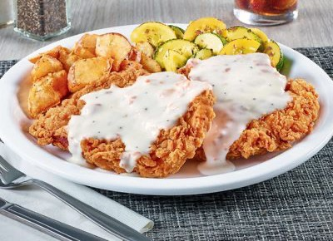Congratulations Pastor Anika!
On Your Official Pastoral Installation
From
Raphael and Sylvia Ehilen

Denny’s Restaurant
1250 Bladensburg Rd. NE, Washington, DC | 202-758-3637
Two Great Locations
Raphael A. Ehilen, Franchisee

Denny’s Restaurant
4445 Benning Rd. NE, Washington, DC | 202-399-7526

First Family

First Family

“Her children arise and call her blessed; her husband also, and he praises her.” Proverbs 31:28 NIV

Pastor Anika
Reverend
WILSOAN-nBRiOkWaN, Ph.D.

“I found god in myself and I loved her
I loved her fiercely”
— Ntozake Shange
”
“ “Connection with God is like the popsicles my dad would give me as a kid… there
was something sacred about that sugary frozen ice on a stick. The simplicity of it connected me to a peace within myself that I didn’t have to strive for… an innate connection with God. This sweet spot was Spirituality…. Simple.. Pure… and DELICIOUS! I wanted to live in this place of
sweet satisfaction and bliss and help others find their sweet spot as well. We are ALL worthy of
an absolutely delicious and abundant life!”
Pastor Anika XOXO

Who is Rev. Anika Wilson-Brown, Ph.D.?
Dynamic. Engaging. Transformative. These three words give witness to what has become the
lifework of Spiritual Leader, Rev. Anika Wilson-Brown, Ph.D. Anika’s innate ability to fuse the
treatment of body, mind, and spirit for a lasting indelible impression on one’s best self and best
life puts her in a category of her own.

Dynamic. One of the most sought-after speakers on the topic of merging faith and psychotherapy, Dr. Anika has spoken on diverse platforms, ranging from arena-sized gatherings to one-on-one small sessions. She uses her platform as a means of helping the individual actualize his or her highest purpose. As the Keynote Speaker for Iyanla Vanzant’s Inner Vision Life Coaching Graduation, Dr. Anika was able to help the audience connect the dots of body, mind, and
spirit in a practical way, charging them to go out into the world with the confidence that they are living both in and on divine purpose. At the National Alliance on Mental Illness, Dr. Anika shared
a groundbreaking presentation on Spirituality and Mental Health, making plain the dire need for people and institutions of faith to both acknowledge and embrace therapy as a method of
healing, in addition to prayer and faith traditions. Dr. Anika is a powerful preacher of the gospel
and skillfully crafts an approach to wholeness that embraces and balances both the activation of

Pastor Anika

Holy Spirit as well as the application of spiritual healing practices. Her message is one of healing and restoration through practical application making her an emerging leader who transcends religious, gender, cultural and social barriers. Her message is Dynamic.

Engaging. It is said that people don’t care how much you know until they know how much you care. This concept is a foundational one for Dr. Anika in her spiritual service and care for both the congregation and individuals. Raised as the eldest child of Rev. Willie F. and Rev. Mary L. Wilson, Dr. Anika learned early in life how to hide in the shadows of low self-esteem and intimidation. Too
shy to speak in public, it wasn’t until her teen years that she slowly began to emerge from the background and find her voice, only to be engulfed by the blazing glare of the ministry spotlight. It is from those moments of uncertainty and despair that Dr. Anika’s sensitivity to
people’s real-world problems developed. To that end, she continues to work tirelessly to reach the people who feel utterly lost, re-engaging them in life to remind them that every day provides an
opportunity for them to start all over again. Her approach is one whereby she helps people identify the root of their problems so that they might be transformed through the healing power of love. Her presence is Engaging.

Transformative. Dr. Anika’s growth over the years give evidence to the power of transformation. As she grew up in Union Temple Baptist Church, she evolved and elevated in various ministry roles ranging from summer camp staff, Youth Counselor, Deacon, Praise and Worship Leader, and Minister of Music. Both licensed to preach and ordained at Union Temple after returning from college, Dr. Anika was ultimately appointed as Assistant Pastor in 2013. Shifting from insecurity to innovative leadership, Dr. Anika utilizes her wisdom, experiences and warm personality to make
great impact on this generation both in and outside of the walls of the church. One of her goals is to help people identify their strengths and abilities so that they are equipped to walk boldly in
them. Many have been inspired and encouraged by her authenticity. Her life is Transformative.
Dr. Anika received a Bachelor of Psychology from Spelman College and a Master of Social Work from Catholic University of America. In 2020, Dr. Anika earned her Doctor of Philosophy from Loyola University Maryland in Counseling Education and Supervision. Dr. Anika believes in the
power of mentorship so she has gleaned wisdom and collaboration from several groups in recent years: Rise Together Mentorship Network, Circle of Sacred Fire Preaching Intensive for Women of Color in Ministry, and Equal Women in Ministry Group. Dr. Anika was recently appointed as Chair of Mayor Muriel Bowser’s Interfaith Council, a body that advises the Mayor of the District of Columbia, the Mayor’s Director for Religious Affairs, and the Mayor’s Cabinet, on various matters, especially those that affect the spiritual, faith and religious well-being of all the residents of the District of Columbia. Dr. Anika has also been featured in numerous media outlets but most notably, an article in Essence Magazine “Standing Tall in Her Stilettos: A Daughter Becomes Pastor of Her Father’s Church” written by Ahmad Greene-Hayes, Ph.D.

Pastor, entrepreneur, leader and therapist are heavy positions to uphold, but Dr. Anika does just that with a tremendous amount of Grace. For her, the most important accomplishment is being a wife to John and mommy to Jendayi, Nyela and Naaji. Her gift and greatest joy is the quality time that she spends with them and her extended family.
Rev. Dr. Anika Wilson-Brown is Dynamic. Her ministry is Engaging. Her life is Transformative.

Greetings
and
Felicitations!!!
Gr tings

It is with supreme joy and divine elation that I am blessed to share in this Investiture of the Official Installation of my daughter to succeed me as pastor of Union Temple Baptist Church.

Pastor “A”, as she is so amicably and respectfully called was NOT APPOINTED to this HIGH HILL of HOLY, DIVINE FAVOR, Dr. Anika Wilson-Brown WAS APPOINTED to this STATION of SACRED SHEPHERD of Union Temple Baptist Church.

When she assumed this pastorate, she was featured in an article in ESSENCE MAGAZINE. The headline of the article was “STANDING TALL IN STILETTOS”. The interviewer began by saying to follow after the renowned work of your father, “you have some big shoes to fill”. To this statement she gave a wittingly incisive retort; I
am not trying to fill his shoes, “I WEAR STILETTOS”!! As a PHD in Psychology she is very aware that symbols con-
tain latent content and are used to redirect warped thinking and disorders of the mind.

This powerful preacher (proud to say she is my daughter) referred to herself as standing in stilettos that she stands tall to continue my legacy, but “in a different way, [her] own way”. She also spoke of standing tall in stilettos to denote her fearless courage to correct the twisted theology, delusional doctrine, sick sociology, and perverted psychology throughout the history of the church that has deemed women unworthy and
unqualified to lead not only in the church but in every segment of society.
Standing tall in stilettos was a profound way to disrupt and destroy the historic myths and lies of paternalistic men and patronizing women that woman should be silent in the church.

This Daughter of Zion adamantly declares that it must be UNDERSTOOD that no one can UNDERESTIMATE or UNDERATE or UNDERVALUE her to UNDERTAKE this assignment because she is UNDERGIRDED, UNDERNEATH by the Everlasting Arms of God.
Executive Pastor Retired (Pastor Mary) and I are Hallelujah Happy and Peacock Proud to see our daughter
assume the mantle of Union Temple as Lead Pastor.

As God said to Jeremiah 1:5 “Before [God] formed [Pastor “A”] in [Pastor Mary’s] womb, [God] knew[her], before [she] was born and [He] set her apart; [God] appointed [her] as a prophet to the nations”. (New International Version).

Further, when I named Pastor “A” Anika, little did I know until genealogical research uncovered that this is the name of her initial ancestor brought to America as a slave from West Africa. Anika means “brilliant,
fearless, favored, unique sweet face. She is all of that and more.
Please join me as I salute and support Rev. Dr. Anika Wilson-Brown and as I do so, “As it is written, eye hath
not seen, nor ear heard, nether have entered into the heart of man, the things which God hath in [store for
Pastor “A” and the Union Temple family”].

Love Dad

Faith of our Mothers!
Faith

2 Timothy 1:5-7 J.B. Phillips New Testament
5-7 I often think of that genuine faith of yours—a faith that first appeared in your grandmother Lois, then in Eunice your mother, and is now, I am convinced, in you as well. Because you have this faith, I now remind you to stir up that inner fire which God gave
you at your ordination. For God has not given us a
spirit of fear, but a spirit of power and love and a
sound mind.

TO MY AWESOME ANOINTED daughter, Rev. Dr. Anika Wilson-Brown.
No words can adequately express how I am feeling today. I’m remembering the first time I held
you in my arms. You had that spark in your beautiful big eyes and would observe and evaluate
your environment. You rarely cried, except for when you were the focus of attention.
As you grew in faith, you quietly became a peer counselor and innovator. You displayed your gifts
in meaningful and unique ways.

Just as the scripture states, your FAITH is a GENERATIONAL BLESSING! It flows from your GREAT GREAT GRANDMOTHER, ELLA BROWN, who was a part of the Unity Church; to your GREAT GRANDMOTHER Rev. Essie Jackson, who was a SPIRITUALIST pastor and seer; to your GRANDMOTHER, Mary Lewis, who introduced Buffalo New York to Kwanzaa. You now stand on the shoulders of all of us who have thrown embers onto the fire that burns within you!

You have overcome so many obstacles. Your perseverance, steadfastness, commitment and dedication to the cause of Christ is an inspiration to everyone you meet. Your ability to persistently
search for solutions to problems and find innovative ways to enhance this great institution is a
testament to your amazing leadership.
The accomplishments over the past 2-years are just the first steps on your journey. God has greater
things in store for you.

I hope you know that I love you from the bottom of my heart and we are so proud of you!
Love Mom

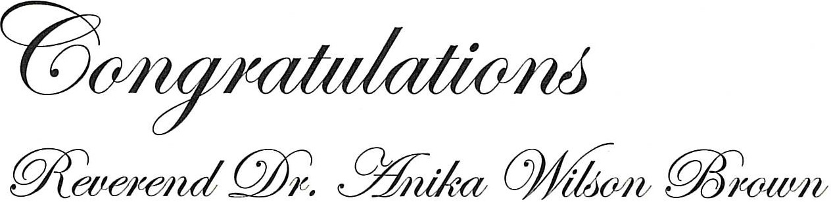

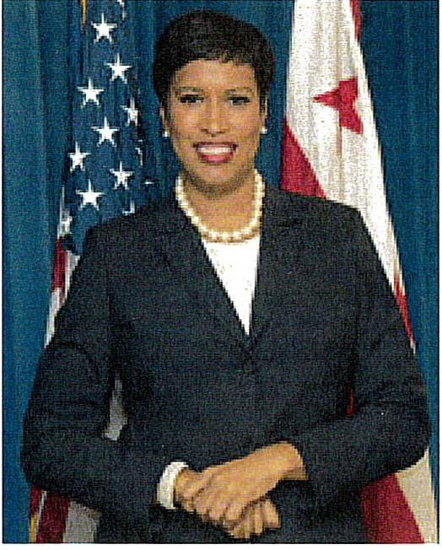
*W*_{AR}*
WASH:Nl GTON

April 23, 2022

As Mayor of Washington, DC, it is my pleasure to extend congratulations to Reverend Dr. Anika Wilson Brown on your installation as the first woman Pastor of the historic Union Temple Baptist Church.

May Union Temple Baptist Church's legacy as a stabilizing force east of the Anacostia River continue to grow as you lead your church in empowering and equipping individuals to live full and abundant lives.

As you gather to celebrate this special occasion, I wish you and your congregation the utmost success in your collaboration to serve all people and fight for justice.

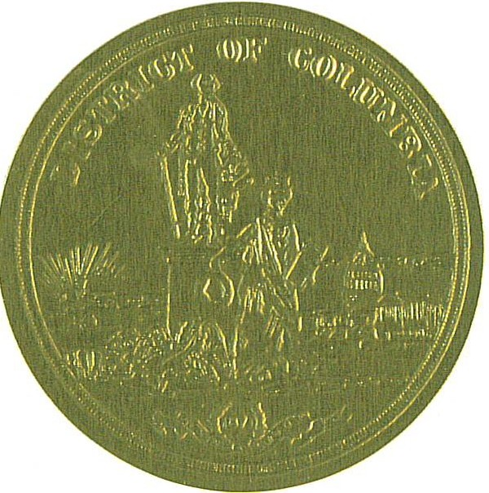
On behalf of the nearly 700,000 residents of Washington, DC, congratulations on your installation and thank you for your service to our community.

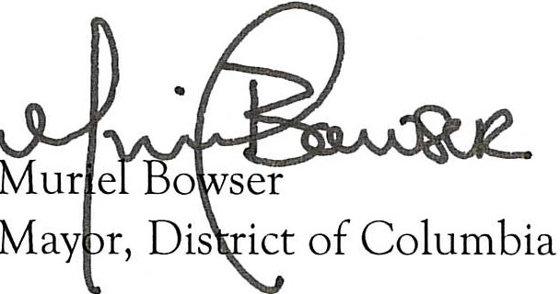

COUNCIL OF THE DISTRICT OF COLUMBIA
OFFICE OF COUNCILMEMBER TRAYON WHITE, SR.
1350 PENNSYLVANIA AVENUE, NW. SUITE 400
WASHINGTON, DC 20004 202.724.8045

Congratulations!

April 23, 2022
Psalm 118:24 (CEV) says “This day belongs to the LORD! Let's celebrate and be glad today.”
On behalf of the residents of Ward 8, we would like to congratulate Reverend Dr. Anika Wilson- Brown on her installation as the Lead Pastor of Union Temple Baptist Church.

This is a historic moment for this world-renowned institution that has been on the forefront of radical change. Union Temple has boldly challenged the status quo and accomplished an incredible list of firsts; the first ordination of women into Baptist ministry regionally; promoting inter-faith worship between Christians and Orthodox Muslims, investing in the development of affordable housing, home ownership, financial literacy programs, health promotion activities, and so much more. Union Temple also engaged with and hosted many of the African American community’s leading warriors in the struggle for civil rights and social justice, including Dr. Dorothy I. Height, Dick Gregory, Rev. Jesse Jackson, and former Mayor Marion Barry.

This great institution has been such a blessing to this community. You have opened your doors to my office and allowed us to use that sacred ground for numerous community events like the State of the Ward Address and the Annual Ward 8 Turkey Drive. I look forward to many new ventures that God has planned under your leadership. We will continue to support you and work together to make a difference, not just by what we say, but what we do collectively.

You have my best wishes that your spiritual leadership will continue to provide an anchor to your members and the community at large.

Again, congratulations Reverend Dr. Anika Wilson-Brown.

Sincerely,
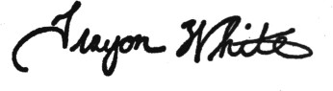
Trayon White, Sr.
Councilmember, Ward 8

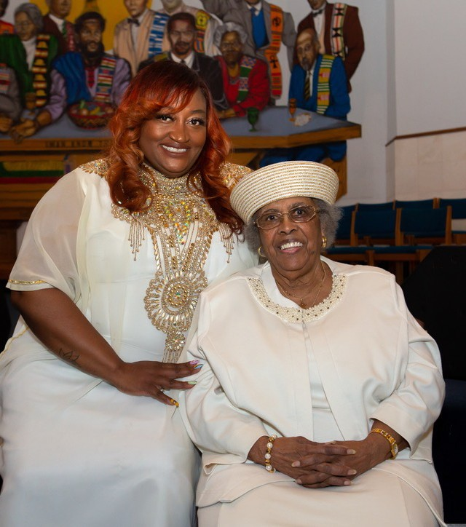

Message from Queen Mother, Janice “Mama Takiya” Crouch Union Temple Baptist Church
Remember the prayer Harriette Tubman prayed, “Lord, I’m going to hold steady on to You and You’ve got to see me through.”
Hold on Pastor Anika Wilson-Brown, Ph.D., God will see you through.

History
Union Temple Baptist Church was founded by the late Reverend Chester R. Smallwood on July 6, 1967 and was officially recognized by the Baptist Ministers Council of Washington and Vicinity as a Missionary Baptist Church in November 1967.

In 1969 after a period of illness, Reverend Smallwood was unable to continue service. Hence, Reverend Simon Beamon served, assisted by Reverend William Roundtree (September 1971- September 1972), and Reverend John Moss (September 1972 - February 1973). In March 1973, Reverend Willie F. Wilson was called by the then active membership of 30, to be the chosen shepherd, and assumed the Pastorate.

In 1990, against incredible odds and opposition, Rev. Wilson led the construction of a $3.5 million church complex in the heart of Anacostia. With its Kente-stained glass windows, the church receives world acclaim for its 30-foot by 19-foot mural depicting the Last Supper. It not only has the image of a black Christ, but also has the twelve disciples depicted as twelve significant Africans and African Americans, among them Martin Luther King, Jr., Rosa Parks, and Malcolm X.

During Reverend Wilson's many years of inspirational leadership, the membership has grown to over 8,000 and God continually adds to the church. Reverend Wilson has distinguished UTBC as one that is on the cutting edge of social, economic, and political changes with the church, community, and the world. UTBC ministries and programs include but are not limited to: The Akoma Project which provides case management to individuals suffering from HIV/AIDS, the Aya Program which provides long term welfare recipients with assistance in the transition from welfare to work, the Harambee House which provides residential and counseling services to court adjudicated juveniles, the Manhood and Womanhood Training Programs which assist adolescents in their transition from childhood to adulthood. Drawing upon African heritage and contemporary economics, UTBC integrates African culture into all aspects of the worship service: development of O.U.R.S. which is designed to sale African- American made products to African-American consumers, making good use of the dancing, music making talents and skills peculiar to our "African roots" and the Tribal System to enhance spiritual development, fellowship, communication, implementation of church programs and policies, and to ensure the general welfare of the church and its members. UTBC serves as host to the Leon Wright Seminary for those within the community who choose to expand their knowledge of the Christian church. Until 2009, UTBC co-sponsored the outdoor festival, UNIFEST, which routinely drew 200,000 visitors each year.

A Week Of Celebration For
Reverend Anika Wilson-Brown, Ph.D.
April 21st – 24th, 2022

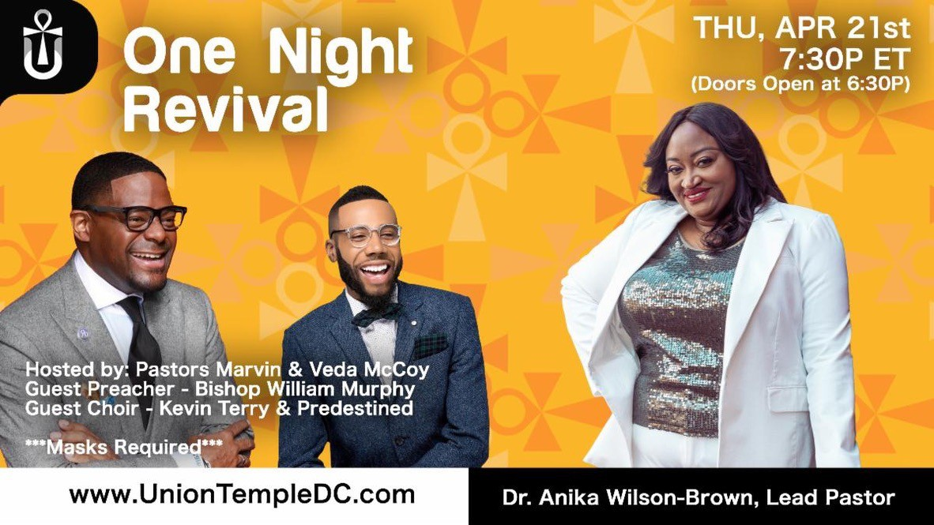
It’s A Celebration ….

Pastoral Installation
Official
Celebration of
SAT, APR 23rd
4P ET
(Doors Open 3P)
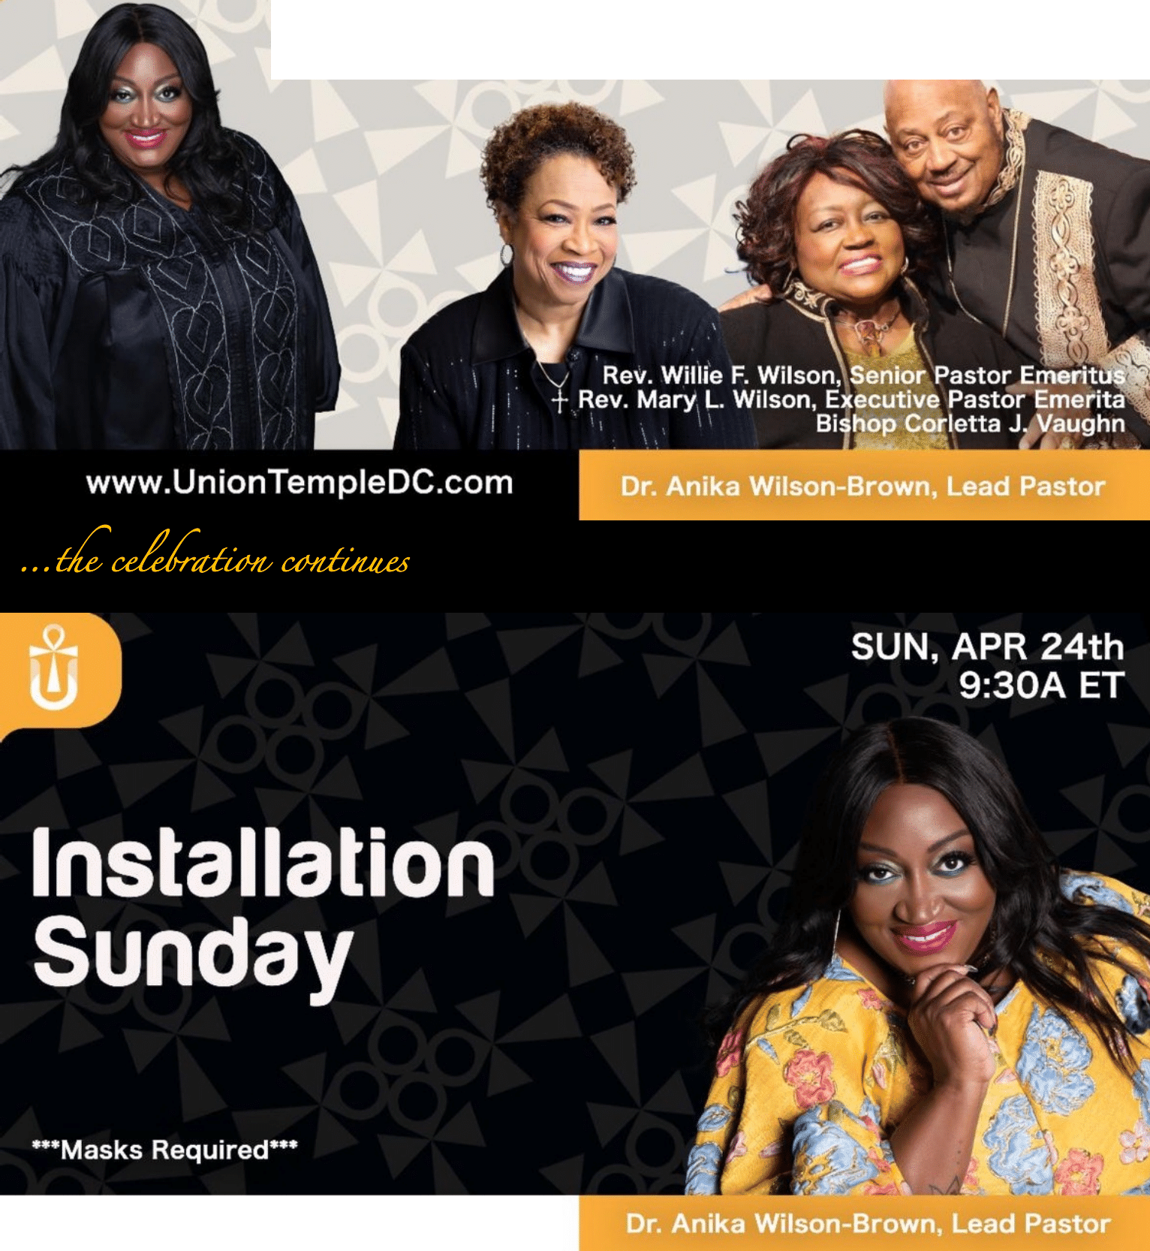Rev. Anika Wilson-Brown, PhD

www.Un ion TempleDC.com

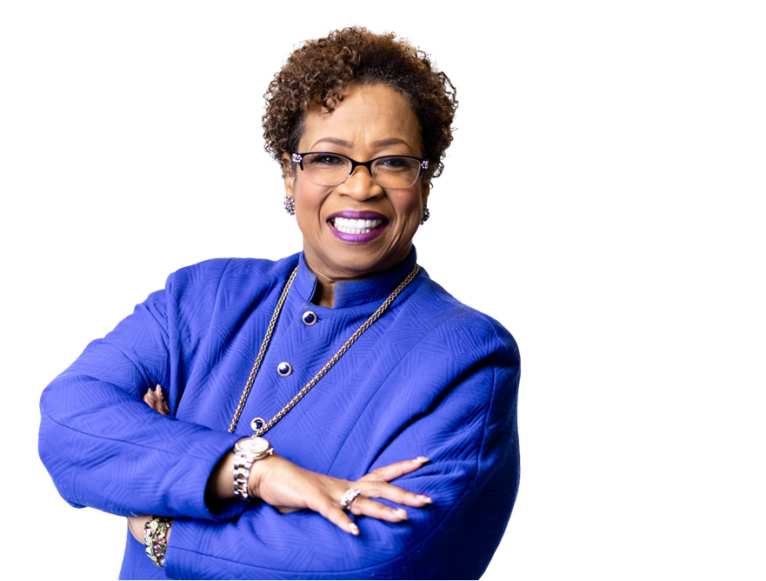

BISHOP CORLETTA J. VAUGHN
Bishop
Senior Pastor of
The Holy Ghost Cathedral

Her Grace Corletta J. Vaughn has been a trailblazer and forerunner among
women in ministry for the last 40 years. From answering the call of God in 1974 to her elevation as a Bishop on November 5, 1995 in the West African country of Nigeria; God has used her life and ministry to impact the Body of
Christ and serve a death blow to the kingdom of darkness tearing down structures of sin, segregation and religious bondage.
Dr. Corletta J. Vaughn is the Senior Pastor of the Holy Ghost Cathedral
Church in Detroit Michigan and Chief Apostle Gofo Tell It Evangelistic Ministry, Worldwide.
As an advocate of scholarship;
Bishop Corletta J. Vaughn is a
graduate of Detroit Public Schools, Wayne County Community College (A.A. Nursing), William Tyndale Bible College (B.R.E. Pastoral Studies),
Oral Roberts University
(M.Ed Post Secondary Administration), Christ for the Nations Theological
Seminary (Doctor of Divinity) and is currently enrolled in Cappella University as a PhD candidate
(Higher Education Administration).

Dr. Vaughn is the mother of two beautiful - gifted daughters; Shannon and Apprille; and multiple thousands
of spiritual sons and daughters in the Body of Christ that know her as a “Mother in Zion”.
Bishop Dr. Corletta J. Vaughn is among
the great company of last-day apostles,
sounding the trumpet calling the Church of Jesus Christ back to Biblical Faith in God, with signs, wonders,
miracles and authentic demonstrations of the Holy Ghost in righteousness and power.
A Celebration of the Official Pastoral Installation of The Rev. Anika Wilson-Brown Ph.D.
HERstory
Making

Legacy. Leadership. Liberation. Love.
“Now Deborah, a prophet, the wife of Lappidoth, was leading Israel at that time.”
Judges 4:4 (NIV).

OFFICIAL CELEBRATION PROGRAM
Rev. Demetrius Norman and Rev. Kalilia “Lili” Wilson
Worship Leaders

Prelude - Drum Call Processional
Procession of Levites & Anthem of Praise UTBC Music & Arts Dept.
Richard Smallwood
Congregational Hymn ….“We’ve Come This Far By Faith/I Will Trust in the Lord” Welcome & Acknowledgements of Clergy, Special Guests & City Officials Prayer of Invocation Rev. Tia Singleton
Prayer Response “Revelation 19:1”. UTBC Music & Arts Dept.

Scripture Readings:
Old Testament Rev. Miriam Niles (Real Life Today)
Psalm Rev. Sheleta Fomby (New Life Church)
Epistle Dr. Vikki Johnson (Soul Wealth)
Gospel Rev. Jimeka Jones Setzer (Community Church)
The Occasion “HerStory is Now” Marcia Olivia Payne. Esq

“Making HERstory” Video Tribute Presentation of the Proclaimer
Song of Preparation “Even Me”… UTBC Music & Arts Dept.
Patrick Lundy

HOMILY
Bishop Corletta J. Vaughn, Celebrant
The Holy Ghost Cathedral

Ministry of Giving
“Great Things”… UTBC Music & Arts Dept.
Ricky Dillard

THE HIGH SERVICE OF INVESTITURE
Rev. Dr. Willie F Wilson, Officiant
Senior Pastor Emeritus
HerStory: The Birthing Rev. Mary L. Wilson, Executive Pastor Emerita
Affirmation from Spouse and Children John Brown Jr., Jendayi, Nyela & Naaji
“Jehovah Sabaoth” Music & Arts Dept with Matari Kucheza
Donald Lawrence
The A’s of Divine Leadership Rev. Dr. Willie F. Wilson, Sr Pastor Emeritus
The Charge to the Pastor Dr. Jasmin “Jazz” Sculark (Victory Grace Center)
The Charge to Brother John L. Brown Rev. Dr. Harold B. Hayes (Real Power AME)
The Charge to Church Rev. Tony Lee (Community of Hope AME)
Anointing & Robing Ceremony Pastor Willie F. Wilson & Rev. Mary L. Wilson
The Prayer of Consecration Rev. Dr. Debyii Sababu-Thomas
(God’s Winning Women Worldwide Ministries, Inc.)
The Declaration Rev. Joann Tally (Divine Creations Ministries)

The Presentations
The Bible Rev. Jackie Nelson (UTBC Ministerial Staff)
The “Keys” Kathy McDaniel, Bashiri Wilson & Tasha Coleman
(UTBC Trustee Chairs)
Remarks & Benediction Rev. Anika Wilson-Brown, Ph.D.
Lead Pastor of Union Temple Baptist Church

Ther e is a peace in know i ng that y ou ar e
wh e r e yo u ’ r e de stin e d to be , a n d wa lk in g in yo u r
div ine p urp ose . Th e r e will be th in gs th a t a rise to
“r ock th e boat .” S tay righ t th e r e in th at p e ace ful
place as t he j our ney pr og r esses. Somet i mes, yo u ma y h a v e to fo l l o w
th e e xamp le o f Je sus and simply r est in and thr ough it. A n d wh e n e xte r n a l
situations ar ound you don’ t e ngage th e same post ur e, y ou can ari se and say PEA CE, b e sti ll. Isai ah 26:3 NIV You w i ll keep i n per f ect peace
th ose wh ose minds ar e steadf ast, because they
trust in you.
Phillipians 4:7 NIV And th e p e ace o f God, wh ich
transce nds all
under standi ng , w i ll g uar d yo u r h e a r ts a n d yo u r
minds in Christ Je sus.

– R ev Li li

Alw ay s keep y our ear s aler t to GOD'S v o ice a n d yo u r
hand i n hi s hand s!!! Cong ratulati ons!

- Rev. J acki e

"I'm r ooting f or ever ybody Black, and I'm
de ﬁnite ly r ooting
fo r Pa s to r A ! B l e s s in gs

- Rev. Shonta

" Congra tula t ions, Pastor Anika
Wi lson Bro wn on yo u r I n s t a l l a t i o n from UTBC's
Minister ia l Staff! "
“Pastor Anika, th ank you fo r yo u r l e a de r s h ip . I a m
gra te fu l fo r yo u r p u rp o se , yo u r
passi on, and y our pow e r. Yo u a r e a t r u e b l e s s i n g ,
and a di vi ne vessel o f G od.
Yo u a r e a c i t y s e t o n a hi ll; a shi ni ng
be a co n o f Go d’s lo v e a n d li g ht. I’m exci ted f or w hat
li es ahead f or y ou. Cong ratulati ons.
I love y ou.
- Mi ni ster Ny esha

“God is with in h e r, sh e will not f all; G od w i ll help her at b r eak o f day.”

“Conside r now, for th e Lor d has chosen Y O U to
bu ild a Te mp le a s a
Sanct uar y. Be st r ong and do th e work."
I Chr oni cles 28:10 (Th e M e ssa ge Bibl e )

-Mi n. L' Tany a I. ( Buck Hatcher)

I w i ll keep my mi nd
stayed on GO D, and M y Hands on the plow, F or ALL Thi ng s W ork
To g e t h e r F o r T h o s e W h o Love The Lor d,
Cong ratulati ons

- Rev. Br enda
"If you can't ﬂy, then run. If
yo u c a n't ru n ,
th e n walk. If you can't wa l k , th e n c ra wl . Bu t wh a te v e r yo u do ,
yo u h a v e to k e e p mov ing for war d"
-Mar ti n Luther K i ng J r.
Cong ratulati ons!

-Rev. Ronni e
De ute r onomy 31:6 "Be str ong and courageous.
Do not fe ar or be in dr e ad o f th e m, for it is th e Lor d your God wh o
gœs with yo u . He wil l n o t leave y ou or
fo r s a k e yo u .”

-Rev. D r. Ing ri d Hay es Burr ell

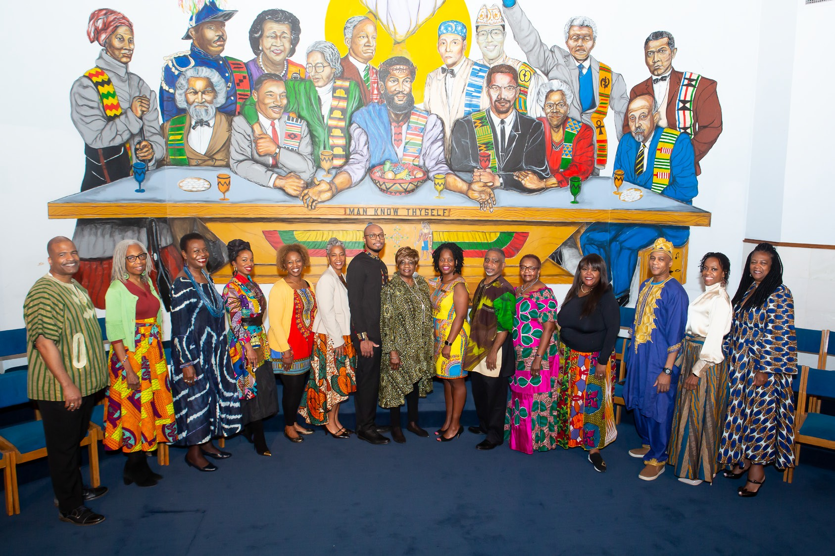

CONGRATULATIONS PASTOR ANIKA!

It is a privilege to commend you on this
Installation milestone. The Board of Trustees stand ﬁrm in our
commitment and ser vice to Union Temple, and in providing you with our wholehearted support to continue its rich legacy.

We look for ward to your visionar y ministr y, remarkable leadership, and spiritual growth of the church. May God continue to bless you.
With sincere appreciation and love,

Board of Trustees

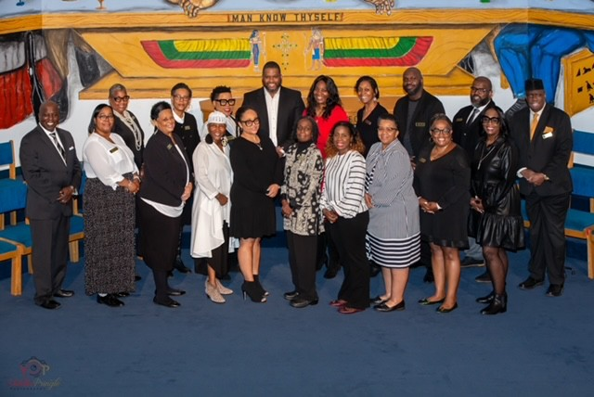

"How beautif ul on the mountains ar e the f eet o f the messenger who brings go o d n e ws, th e go o d n e ws o f p e a c e a n d sa l v a tio n , th e n e ws th a t
th e God o f Isræl r e igns!" Isai ah 52:7

Pastor Anika, Congra tula t ions on y our second anniv ersary as our Lead Pastor , and on the officia l passing of the
torch! lWe are excited to cont in ue working a longside y ou, and to do our
par t to make y our vision f or this ministry a rea l ity .

- The UTBC Deacon Board

P E AC E & L OV E

The Union Temple Baptist Church Praise and Worship Ministry

Congratulates Reverend Dr. Anika Wilson-Brown on her
Pastoral Installation!!!

We Love YOU!
We Support YOU!
#TeamPastorAnika
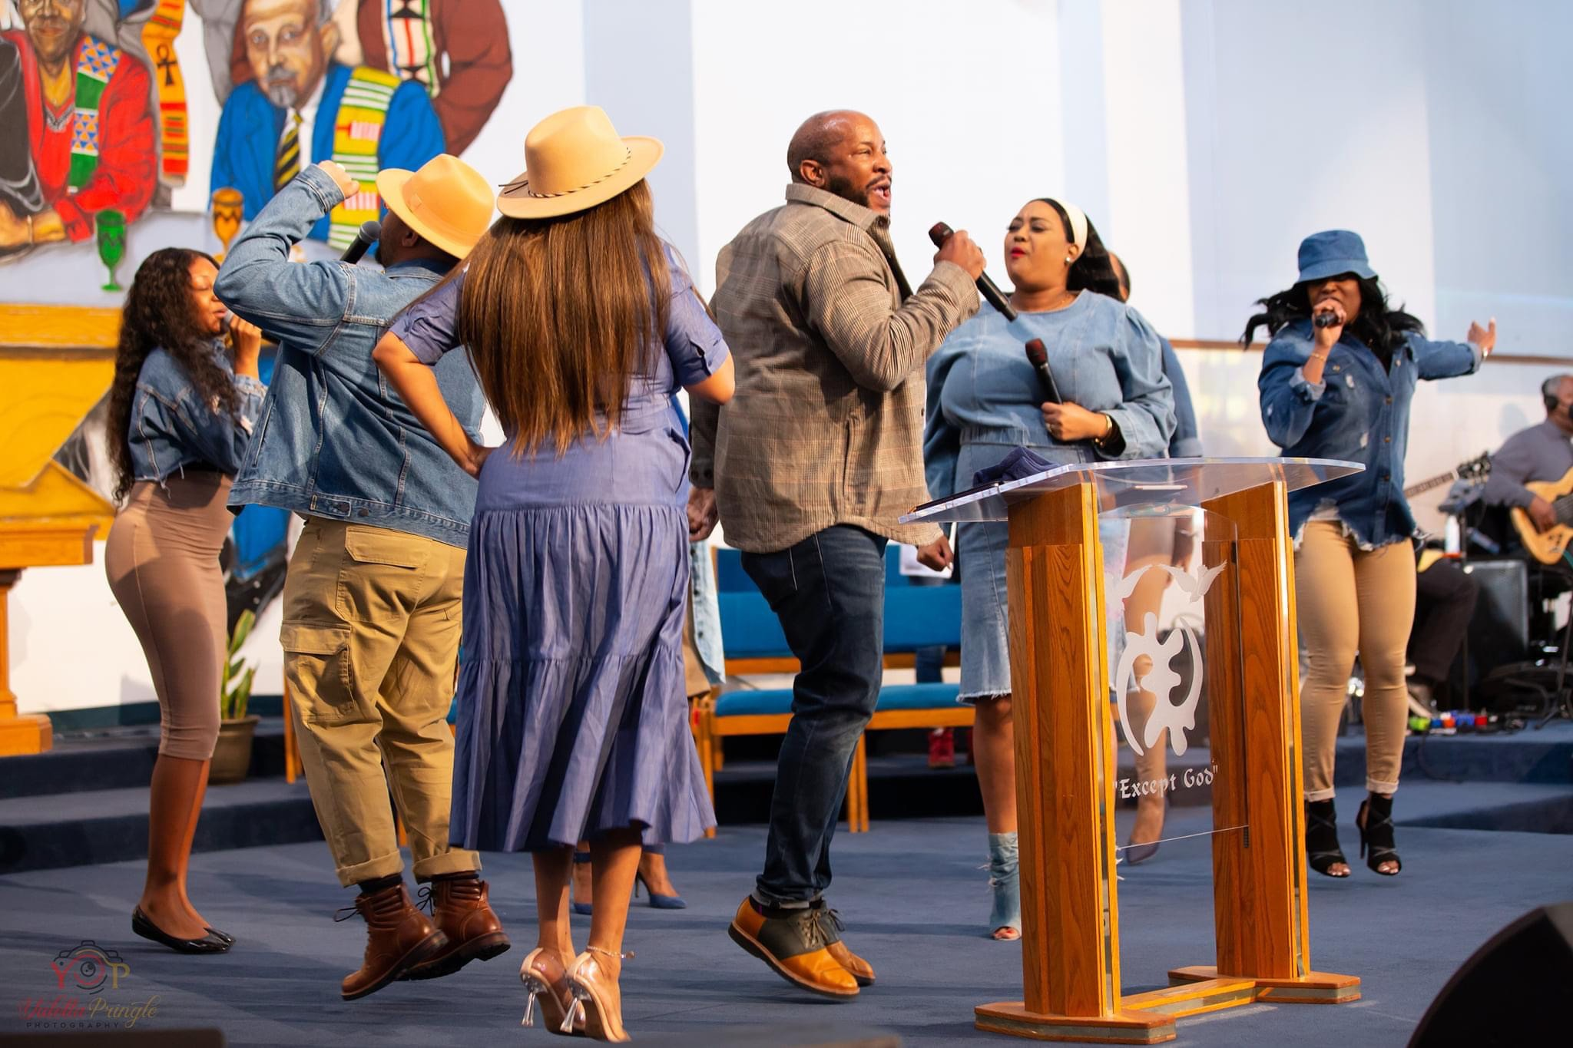

Min. Tia Singleton Minister of Worship & Arts | Sis. Cherece Murrell  Asst. Praise & Worship Leader | Bro. Mike Scott, Jr. Minister of Music

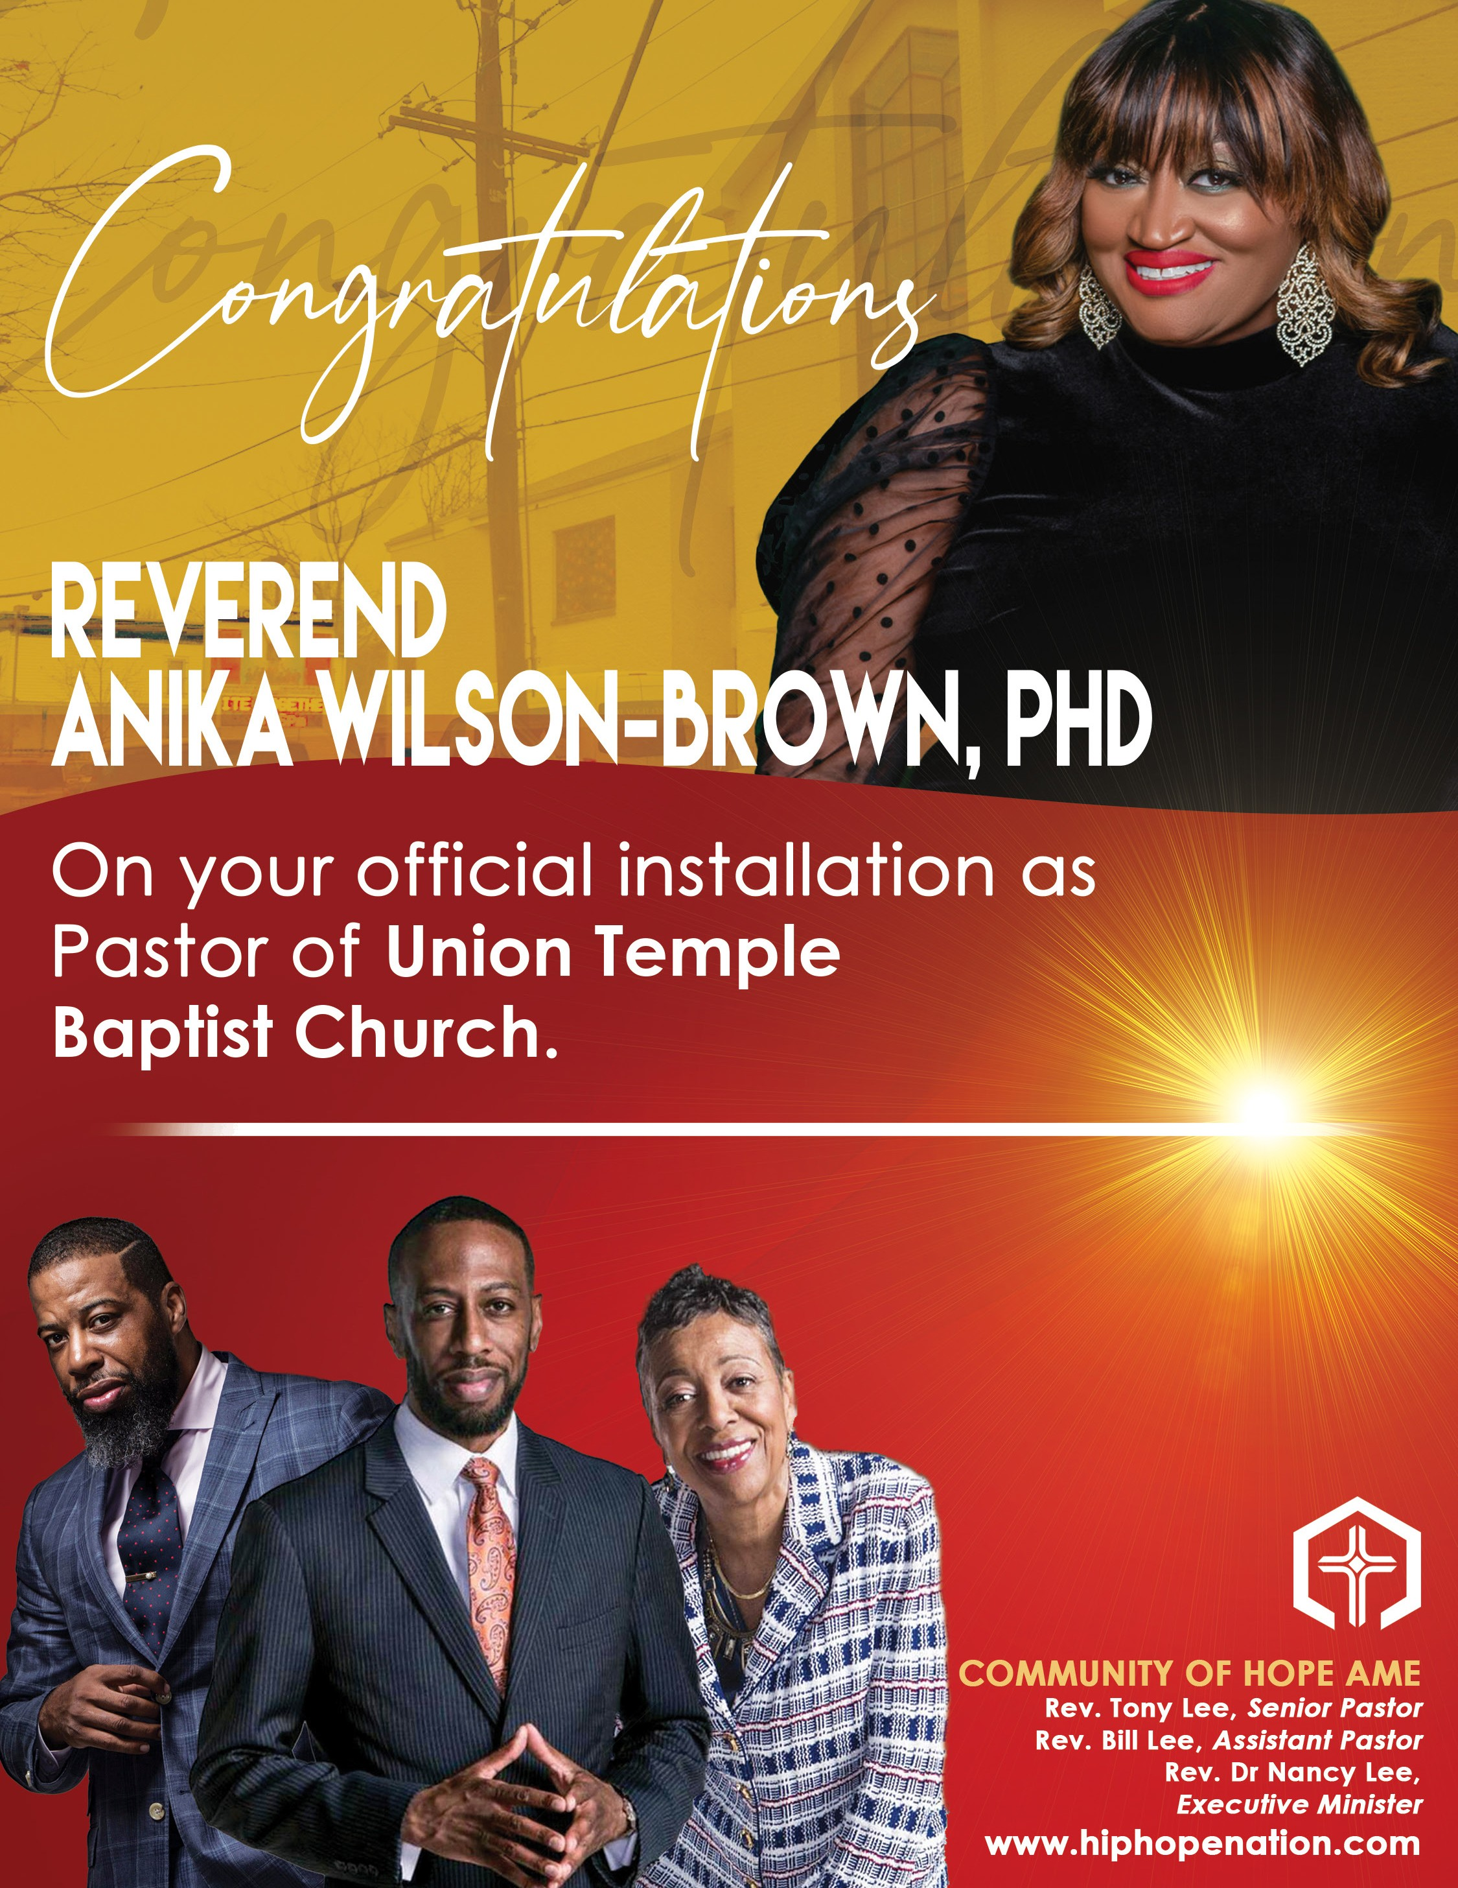

<C" )»ÏØË» A¢»ê

Congratulations!
On the Retirement of Reverend Willie F. Wilson and to the installation of
Pastor Anika Wilson-Brown, Ph.D.

We at NCG celebrate with you the good work that God has done and wil continue to do in
your ministry !

“Being conﬁdent of this very thing, that He who has begun a good work in you will complete it until the
day of Jesus Christ;” Philippians 1:6

0VS .JTTJPO JT UP 1SPUFDU :PVS .JTTJPO ¥

Congratulations to
The Reverend Dr. Anika Wilson-Brown
Upon Your Installation as Pastor, Union Temple Baptist Church

Joyce Garrett and Family and Your Many Friends from the
Eastern High School Alumni Choir

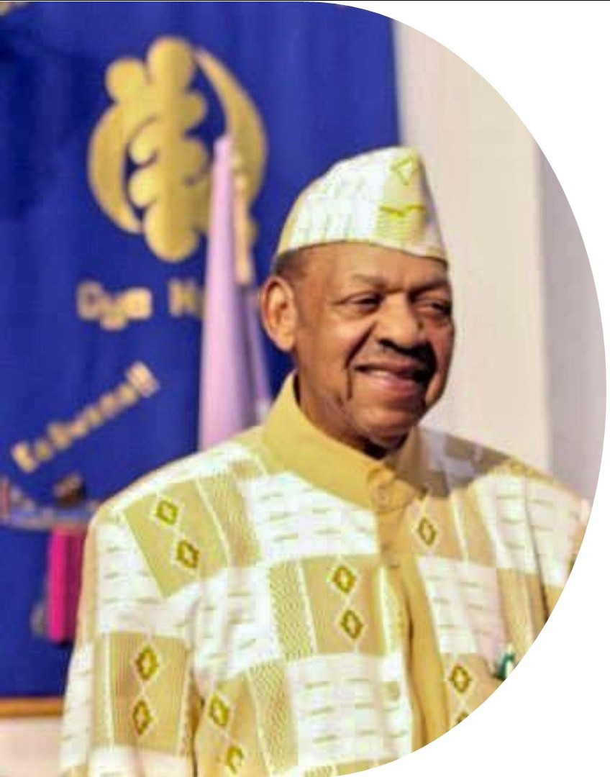
CONGRATULATIONS!

To
Rev. Dr. Anika Wilson-Brown

On your installation as
LEAD PASTOR

of Union Temple Baptist Church

P Is for the PREACHER God called you to be

A Is for the ANOINTING gifted to you to minister with His leading

- Is for SHEPHERD appointed to lead God's flock

- Is for TEACHER who studies and shares God's Word

0 Is for OBEDIENCE, a heart of compliant submission to Him

R Is for RIGHTEOUSNESS by which you live and are blessed

May our good Lord be with you always!
Brother Vernon E. Hawkins

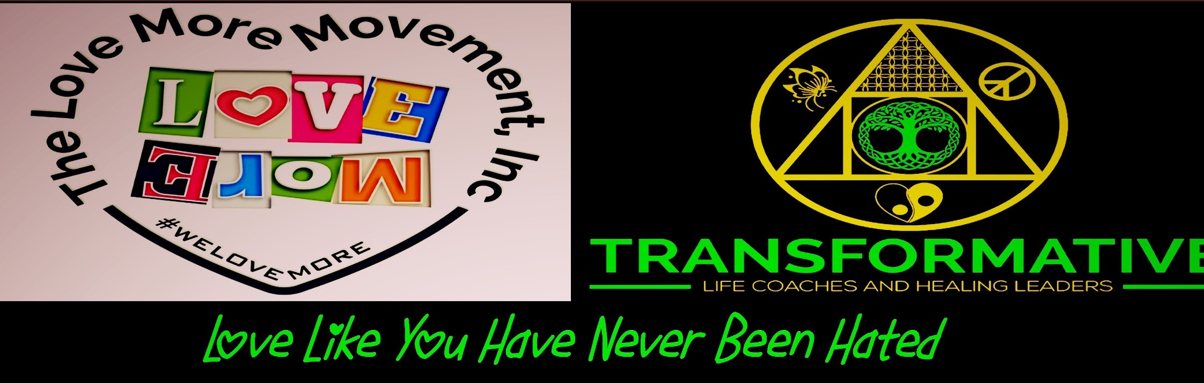

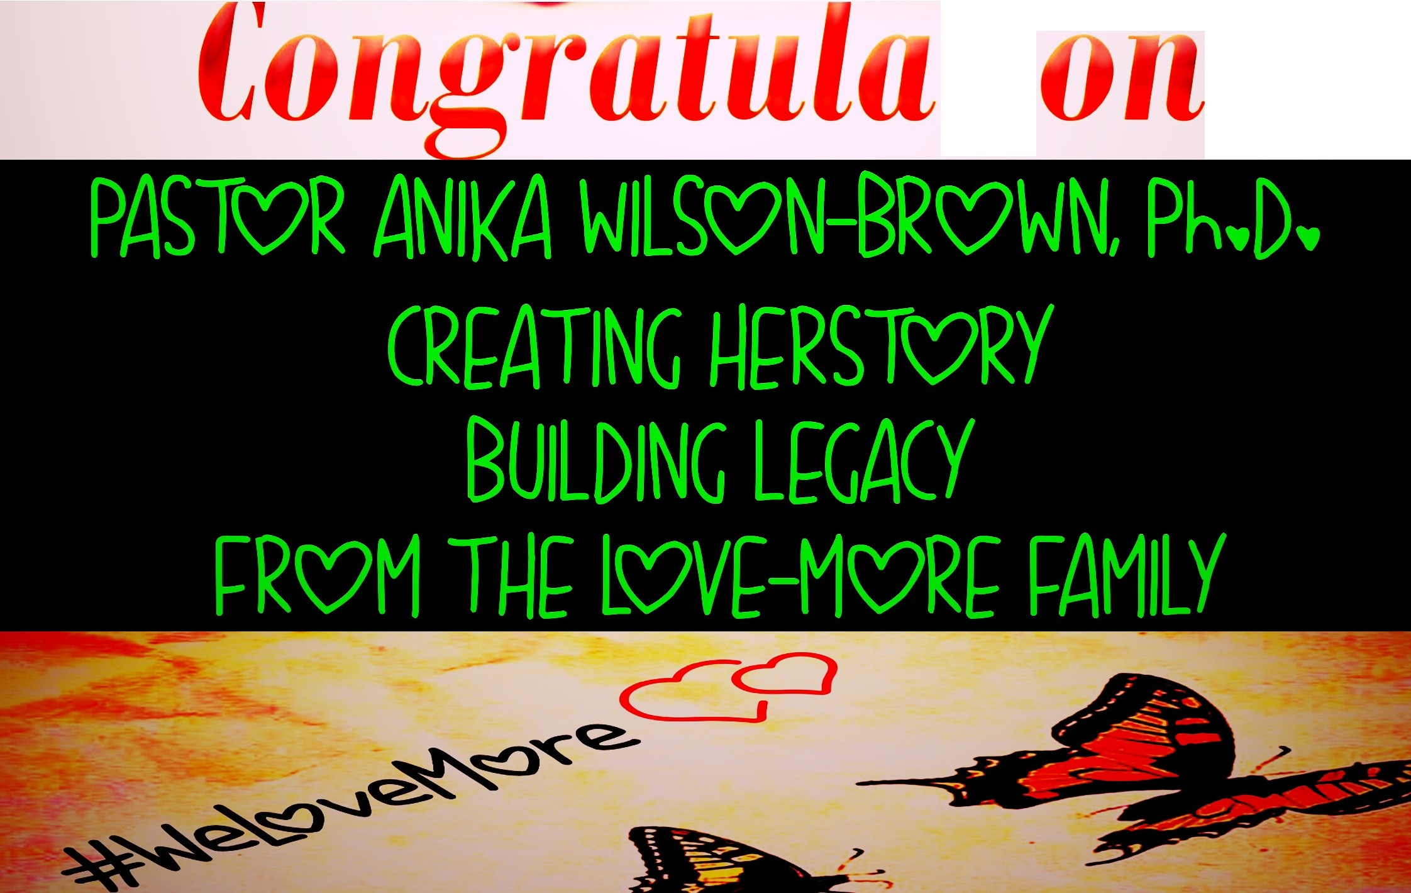
ti
s

AWB SIGNATURE SACRED SPA PRODUCTS

These products combine the benefits of spirituality, cognitive therapeutic principles and aromatherapy. I create these products in my kitchen to uplift the mind, heal the spirit, and nourish the soul. I take special care in curating unique products by selecting essential oils that will invoke a specific prayer for the customer.

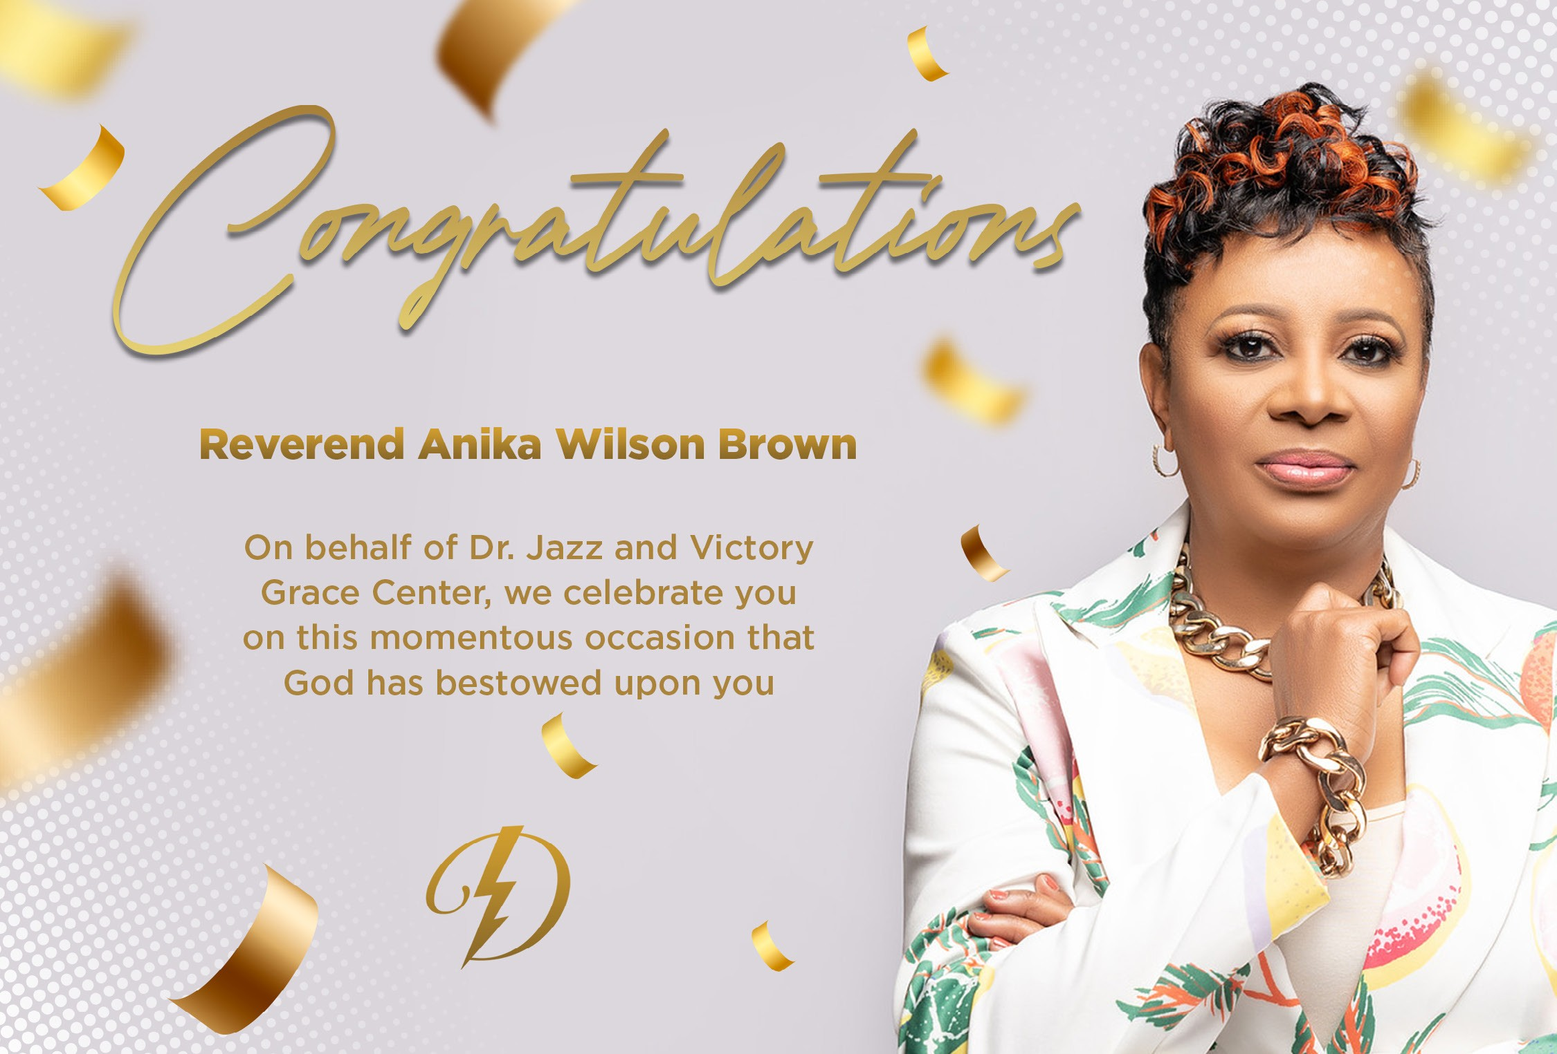Congratulations!!
Dr. Anika Wilson-Brown, my Lead Pastor of Union Temple Baptist Church. I am so thankful to have you in my life. Thank you for your prayers, support, encouragement and wise counsel.

I love you and so proud to call you my Big Sister and Friend!

But as it is written, Eye hath not seen, nor ear heard, neither have entered into the heart of man, the things which God hath prepared for them that love him. 1 Cor 2:9

R E A L L I F E T O D A Y C H U R C H
1 6 1 1 4 T H S T R E E T , N W | R L T C E X P E R I E N C E . C O M

Pastor Anika,

We are so honored to celebrate this God-designed moment in your amazing journey. You are a leader's leader and true visionary. Congratulations on your installation!
W I T H L O V E ,
Pastor Miriam Niles, Brother Ian Niles, and the Real Life Today Church Family

To Our Lead Pastor, Reverend Anika Wilson Brown, Ph.D.

The Ogboni Society of Union Temple Baptist Church is grateful to almighty God for blessing us with an awesome Lead Pastor. The great work that God has done through you during these challenging times is a testament to your resilience, perseverance, commitment, and dedication to the cause of Christ.

Continue to speak truth to power! Be you! Be bold!

We are surrounding you with prayers.

Love and blessings!
Ogboni Society

Congratulations Dr. Anika Wilson-Brown
on your Installation and successful Second Anniversary as Lead Pastor May God continue to bless and direct you

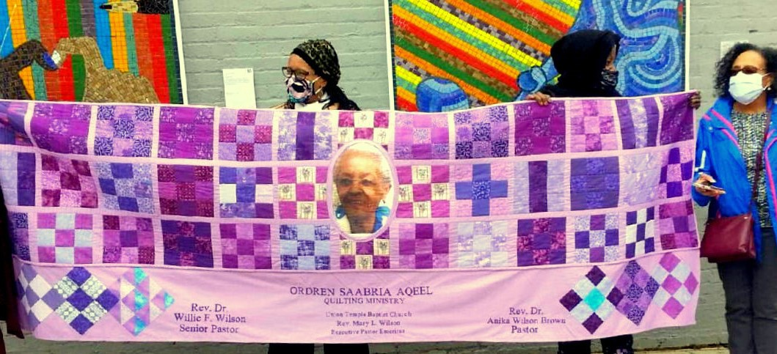Ordren Saabria Aqeel Quilting Ministry
Maana Sikose Mijiza
Woman keeps tradition, she works with her hands

Congratulations Pastor A!
Many are called but few are chosen.
You lead our congregation by opening God’s word, and then you live your life reflecting all we’ve heard.
You are committed to the Ministry and our Partners at UTBC.
We are grateful for your leadership.
You continue to be the glue that binds us all together.
We are proud of you, and we love you immensely!
AWB Experience Team

What a great joy it is for ever one who knows and loves ou to see something so amazing happen in your life! Your official installation as our Lead Pastor symbolizes the everlasting commitment you' ve akead made in our heart to God and U-\e UTBC family.

We thank God for you and are grateful to Hint for all the amazing things we've accomplished in these challenging times. Our chtu·ch is blessed to have a Lead Pastor whose faith shines brighter than any star, is bold, courageous, and speaks huth to power.

Sincerely,
TheWomen's Minish'}' of Union Temple Baptist Church

Ephesians 6:7
With good will doing service, as to the Lord, and not to men.

Congratulations to our Lead Pastor,
Dr. Anika Wilson-Brown
Union Temple Usher Board

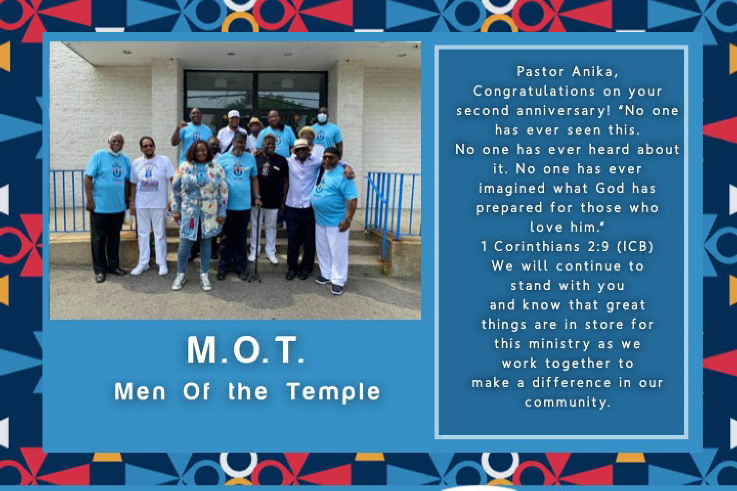C o n g r a t u l a t i o n s P a s t o r A .
“With loyalty will we end eavor t o ai d i n y our
wo rk , a n d de v o te
our selves to the w elf ar e of t h i s m i n i s t r y.”

- The Hea lth Ministry
Marcel la Somuah
Director Of Hea lth

Annie Reed
Chief Consultant

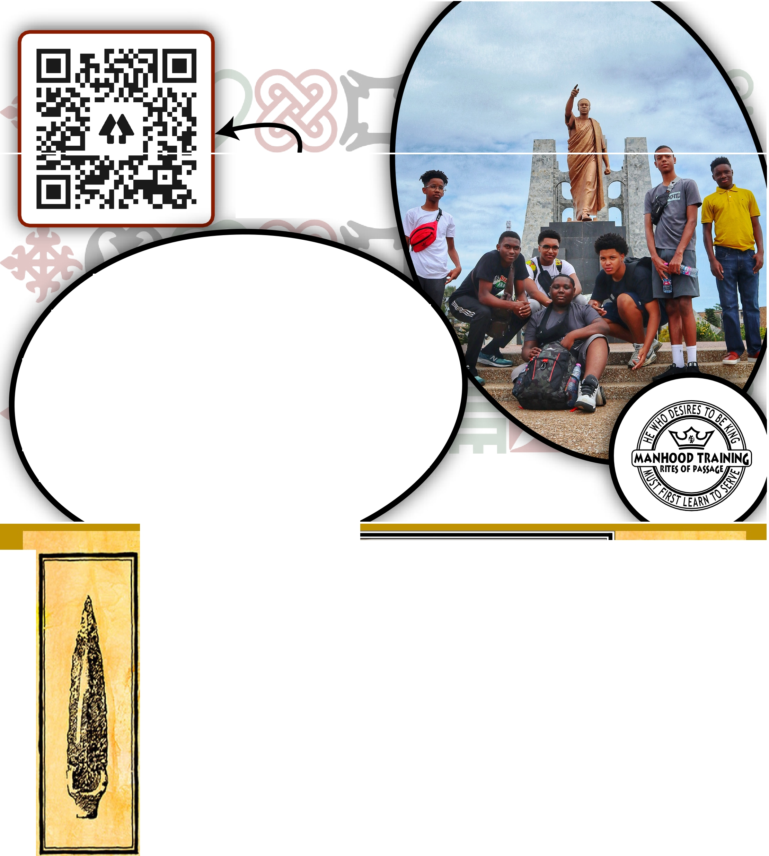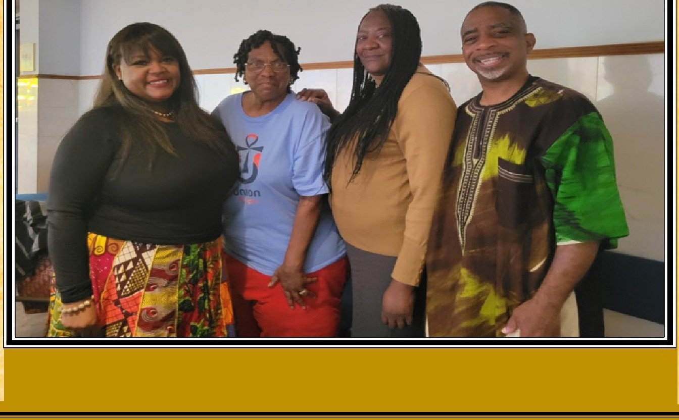

SCAN THIS (ODE TO LEARN MORE

ONGRATULATIONS [D)R A
WE ARE THANKFUL FOR YOUR COMMITMENT TO THE YOUTH AND THE GREATER DC COMMUNITY AND EXCITED FOR THE THINGS WE ARE GOING TO ACCOMPLISH TOGETHER. WITH LOVE,
MANHOOD TRAINING RITES OF PASSAGE
THE MISSION
OUR PROCESS IS DESIGNED TO NURTURE, DEVELOP, AND EMPOWER THE SPIRIT, MINI>, AND BODY OF YOUNG MEN OF THE AFRICAN DIASPORA. IT IS ALSOl>ESIGNEI> TO PREPARE OUR YOUNG MEN TO ASSUME RESPONSIBILITY AS TOMORR OW' S HUSBANDS, FATHERS, LEADERS, WARRIORS, ROLE
MOD ELS, ENTREPRENEURS, AND MENTORS.

LEARN MORE AT:
MANHOODTRAININGINC.COM

Congratulations to our
Lead Pastor, Anika Wilson-Brown, Ph.D From the Tribe Simeon

CONGRATULATIONS AND BLESSINGS TO YOU PASTOR ANIKA!

~ ~ ON BEHALF OF THE MIGHTY TRIBE OF UJIMA ~ ~
WE SEND OUR LOVE AND APPRECIATION TO YOU AND WE JOYOUSLY CELEBRATE YOUR INSTALLATION AS LEAD PASTOR OF OUR BELOVED UNION TEMPLE BAPTIST CHURCH!
~ ~ ROSALYN L. COATES, CHAIR ~ ~
~ ~ SHARON CAMPBELL~ ~
~ ~ DEANNA ECHOLS ~ ~
~ ~ ELYNORE HERRON ~ ~
~ ~ CRYSTAL JOHNSON ~ ~
~ ~ CATHERINE THOMAS ~ ~
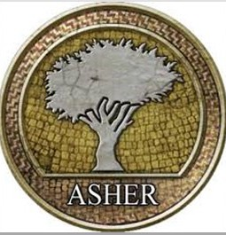

the tribe of ephraim congratulates
pastor anika-wilson brown, ph.d. on her milestone installation as lead pastor of
union temple baptist church april 23, 2022

CONGRATULATIONS
PASTOR, DR. ANIKA WILSON-BROWN

WE LOVE YOU,
MAY GOD CONTINUE TO KEEP AND BLESS YOU.

TRIBE OF ASHER

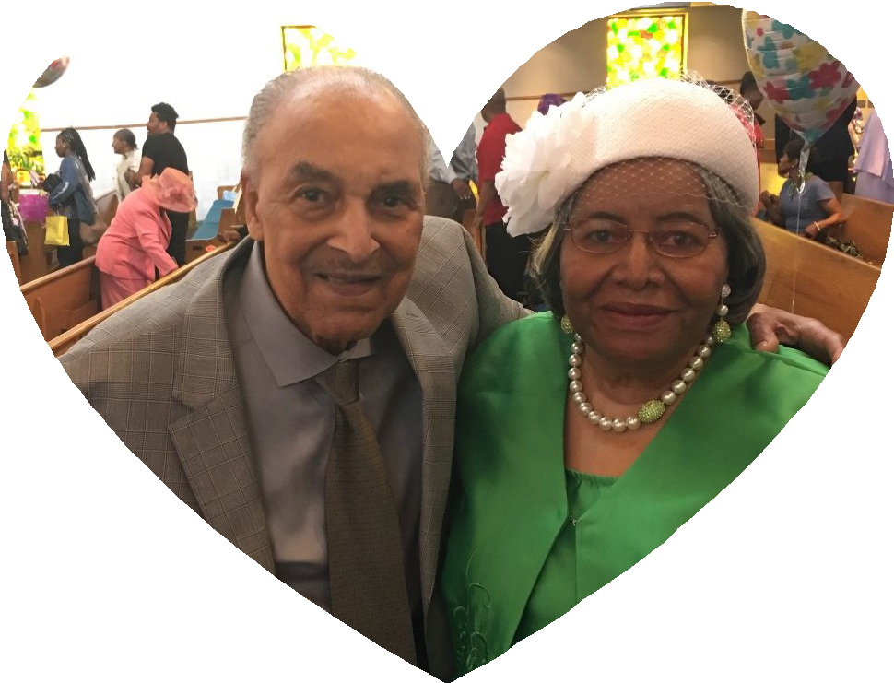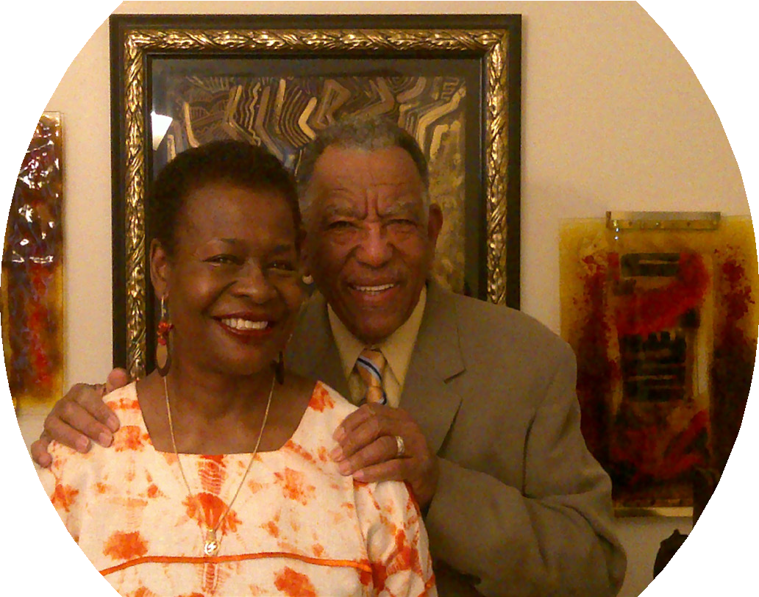Congratulations Pastor Anika!
From the Rooney Family
In loving memory of our parents, Baba Shirley R. Ramsey, Jr and Momma Lozetta Ramsey

Faithful Members of Union Temple Baptist Church 1978 - 2019

Rev. Dr. Anika Wilson-Brown

Blessings and Congratulations to You on your Installation as
Lead Pastor
of
Union Temple Baptist Church

With Love,
Paul and Rosalyn Coates

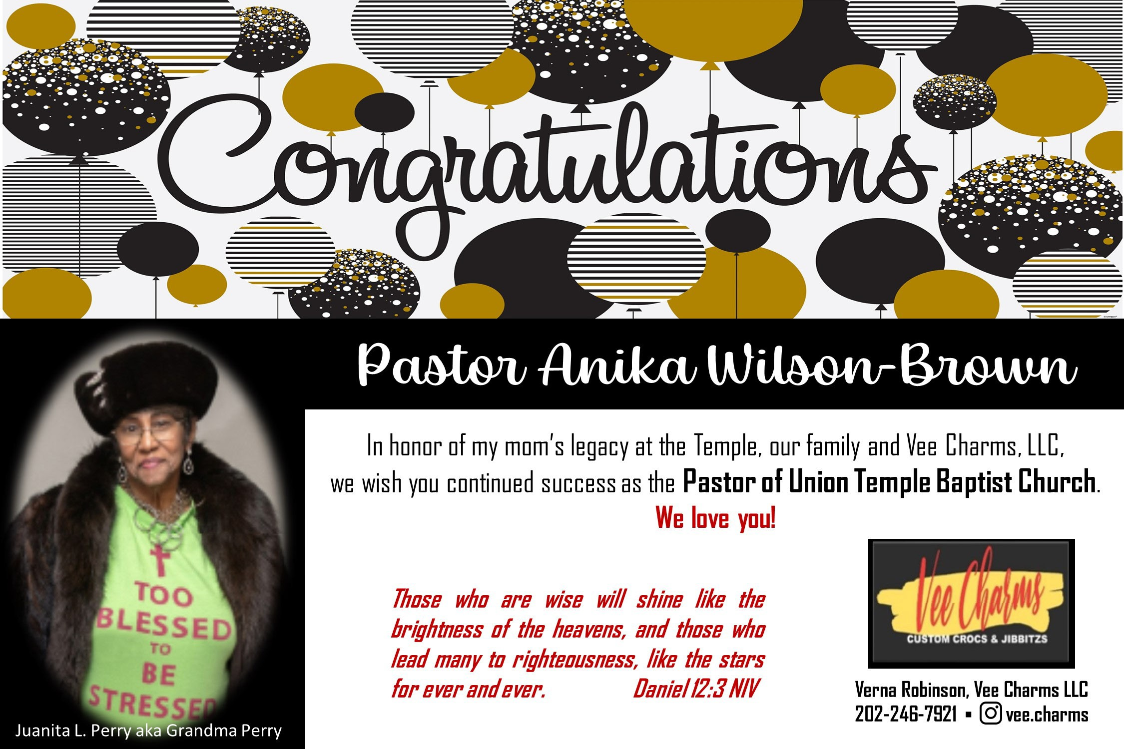Congratulations Pastor Anika Wilson-Brown, Ph.D.
from

Quality Family Care in a Christian Setting That’s Fine Living….
Call for Information or an Appointment to Visit (202) 409-1366
www.finelivingcare.com • finelivingcare@gmail.com

Fine Living Care I | Fine Living Care III | Fine Living Care IV
4605 Navy Day Place | 8513 Pinta Street | 2901 Logan Street
Suitland, MD 20746 | Clinton, MD 20735 | District Heights, MD 20747

FITNESS
- Fitness Coaching
- Exercise Classes

Tania Wright, Owner

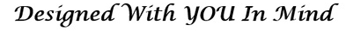

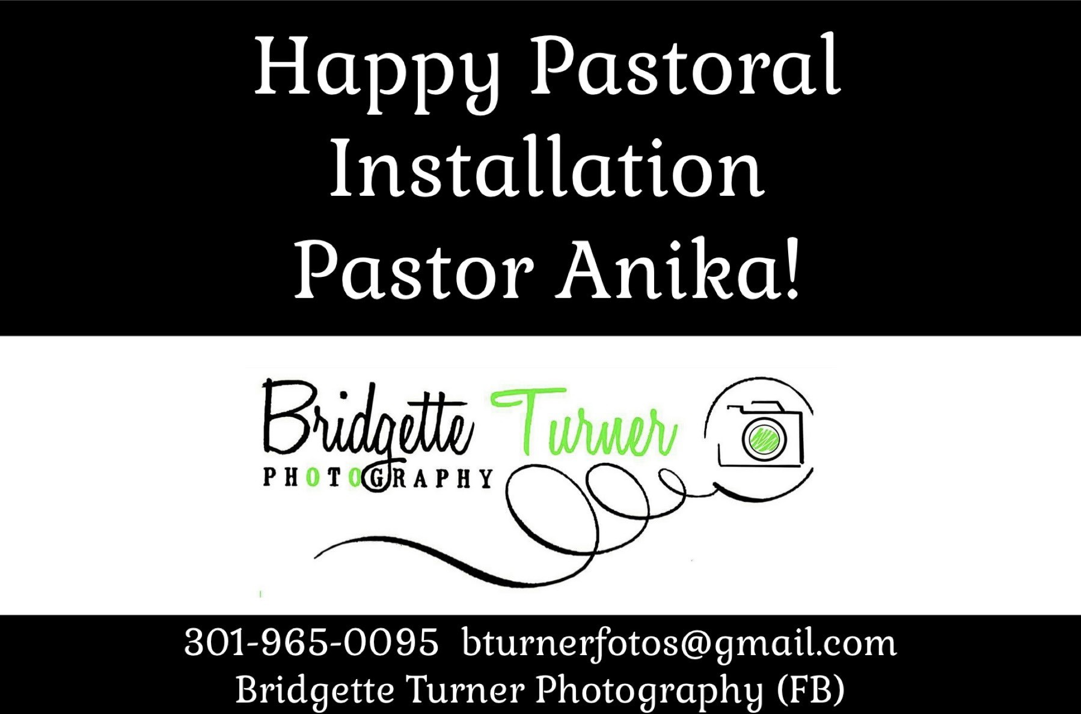

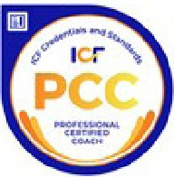

Ge t Your Free 30-MimI.e
SUC•CESSJSOLUtTIO S
You Can Ry llidierThan YouE\'erDreamed
Pos sible!

\ Succe ss Solutions, Inc.
PO Box 571
Port T obacco, 20677

\ Vebsit.e: ,m w, ., ]¥ Succe ssSolutious.com
Phone: (301) 399-1962
Em ail: \, Yfake ll@\, J¥ Suc cessSolutious.com

Looking for YO lll' Breakthro ugh ? In a career or personalrt an sition? If you were 5% more , where would you be now?
Come find out what other s have alread y di sco ver ed .
Break.thr<>ldi,
Consulratioo
Limited A\rulabilitv - Act :\"o w!
Wi lliam} . Makd!Jr.
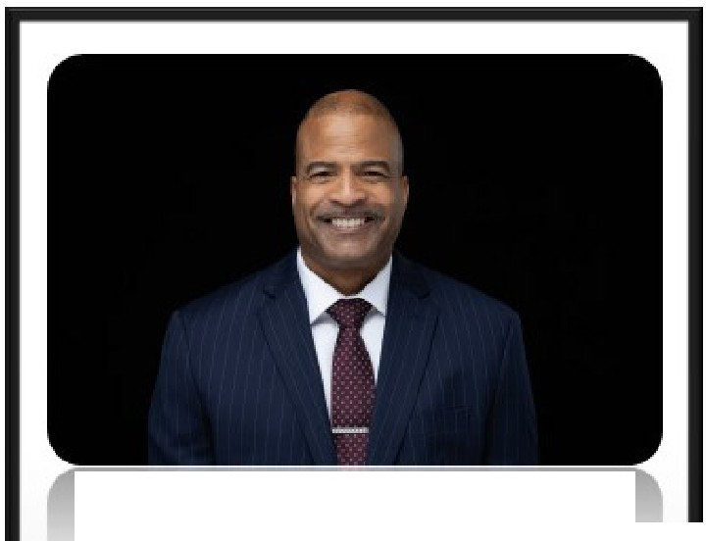ln temab.01J:tlEx ecutin , LeadershipC ooch
Congratulafo ns
Rev. Dr. Anika Wilson-Brown on your Tnstallation as
Lead Pastor of
Union Temple Baptist Church! May God conti nue to bless you and your leadership of thisgreat m inistry.
Speaker
Trainer

Fly Higher- Inner-Core Leadership Ad \':llll"IJ' Mast:,ri,gYourself to Manifest Yaur Destiny Leader.hipfcr the 21• Cemmy
The DEil=dershipAm.ioc,g,, Leadiogwilh Emotion:tl Int:eJliwnce

&Wlr
Rw. Anika w -6ww-n, P
railblazer IGod-filled IGod-led ICommunity Builder ITruthteller ITe
mgIYouTube: Kelektiv Media Grouplwww.kelektivmediagroup.comIinfo@kelektivmecl"
A Minority/Woman/Veteran-owned Business

Catherine Thomas
Realtor, SRS, RSPS, CIPS
Long and Foster Real Estate 9300 Lottsford Road Ste 500
Largo, MD 20774
CONGRATULATIONS
Anika Wilson Brown
on your installation as lead
Pastor of Union Temple Baptist Church. I pray that

God’s divine guidance

202 423-6701: Mobile 301 249-1600: Office
www.Longandfoster.com/catherinethomas Catherine.thomas@longandfoster.com
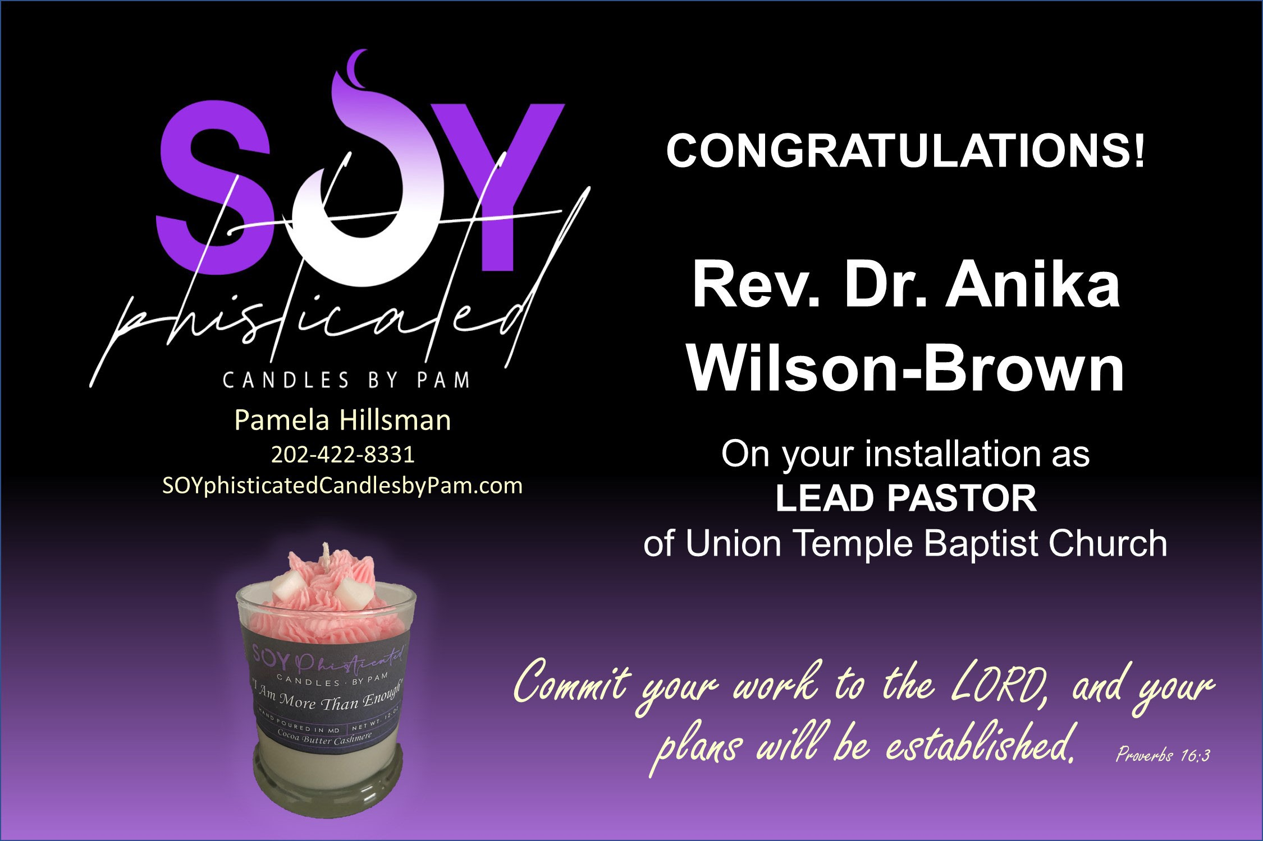"Always at your service"

forever lights the path of your leadership and thank-you for answering the call.

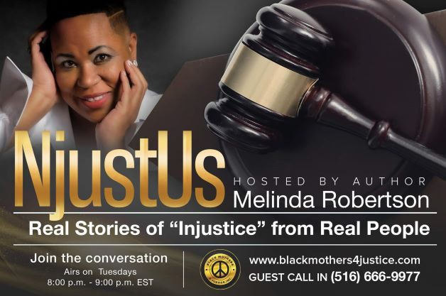

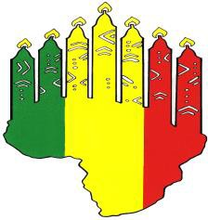

AfricanFire Angel, LLC Africanfireangel@gmail.com 202 417-6617
Facebook – Africanfire Angel, LLC Instagram - @africanfireangel Website coming soon!
To the Best Lead Pastor in Herstory Pastor A,
You have creatively and with determination fulfilled the divine assignment as the Lead Pastor of Union Temple Baptist Church.
The Creator has ordered your steps and will use this amazing institution to reach our Brothers and Sisters of the world!
With Much Love and Congratulations,
Lisa “The Candle Lady” Ayers

Higher Purpose, LLC Higherpurposeentertainmentllc.com g.ayers1987@gmail.com
202 713-5145
Facebook – Higher Purpose Entertainment Group, LLC Instagram - @higherpurposedj Twitter - @Boogiebabyg
Pastor Anika Wilson-Brown Congratulations on your Pastoral Installment!
We are so grateful for your wisdom and courage.
Union Temple Baptist Church is blessed to have you as a Pastor and also continuing the legacy of this institution.
Thank you for the love and support over the years.
Geron “DJ Renaissance” Ayers

Congratulations
Reverend Anika Wilson-Brown, Ph.D.
On your Pastorship at Union Temple Baptist Church
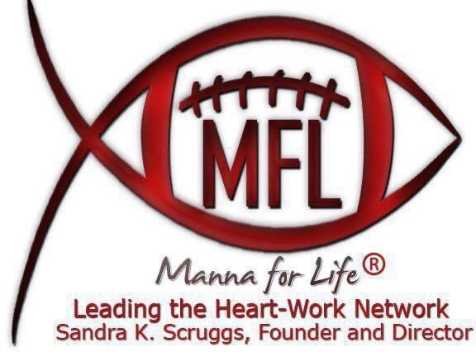

L9l. V E/RW!E &' CCYM.P'A.WY
(.20.2) 746 - 6108

HAIR AND BODY PRODUCTS

OUR PRODUCTS ARE HANDMAD E WITH PUR E AND NATURAL INGREDIAN TS FOR ALL TYPES OF HAIR AND SK IN. EACH INGREDIAN T IS CHOSEN WITH YOU IN MIND. OUR FOCUS IS ON STRONG & H EALTHY HAIR AND SOFT & SMOOTH SKI N.
OUR SALTS ARE CREA TED TO BRING YOU A PERSONAL SPA EXP EIREN CE IN THE COM FORTS OF YOUR OWN SACRED SPACE.

OUR HAIR PRODUCTS

BLACK SOAP SH AM POO; H AIR COND ITIONING BUTTER; HAIR GROW TH OIL; FENUGREEK M OISTURIZING HAIR SP RAY.

OUR BODY PRODUCTS

Me dit atio n Bath Salts; Mil k Bath Salts, Lave nde r Spa Bath

IG: @iamkalifaisoke

FACEBOOK: Kalifa lsoke Hair Growth EMAIL: kalifaisoke@gmail.com
8 ·
Better Beauty Hair & Body Care

CONTACT: 301-787-9881

PATRONS
Congratulations Pastor Anika Wilson-Brown, Ph.D.
Airet Global Communications, LLC AKWAABA Hospitality Ministry Deacon Alethea & Sister Asja Bard Sister Angela M. Davis
Sister Angela McKnight Mr. & Mrs. Rodney Vines
Trustee Charles & Sister Valerie Matthews Deacon DeShawn McMillian & Family Dollies 4 the Hollies
Sister Greta Giles
Deacon JuVonne Newsome & Family Trustee Kathy McDaniel
Rev. Dr. Kelly U. Farrow Sister Kyleia Plaskett
Minister L'Tanya I. Buck-Hatcher Deacon Lester Hatcher, Emeritus Sister Grace Ayers
Sister Maggy Lewis Majeshi Ya Mungu Security Ministry
Deacon Nadine Feaster Deacon Rita Daniels Deacon Robert Stradford
Trustee Rosalyn & Brother Paul Coates Sister Sandra Brown
Sister Shelia West Trustee Tasha Coleman Tribe of Benjamin Tribe of Dan
Tribe of Gad Tribe of Judah Tribe of Reuben Tribe of Umoja
Trustee Victor Plaskett Pastor Yolanda Minor Trustee Yuletta Pringle Sister Yvette Brown-Plaskett

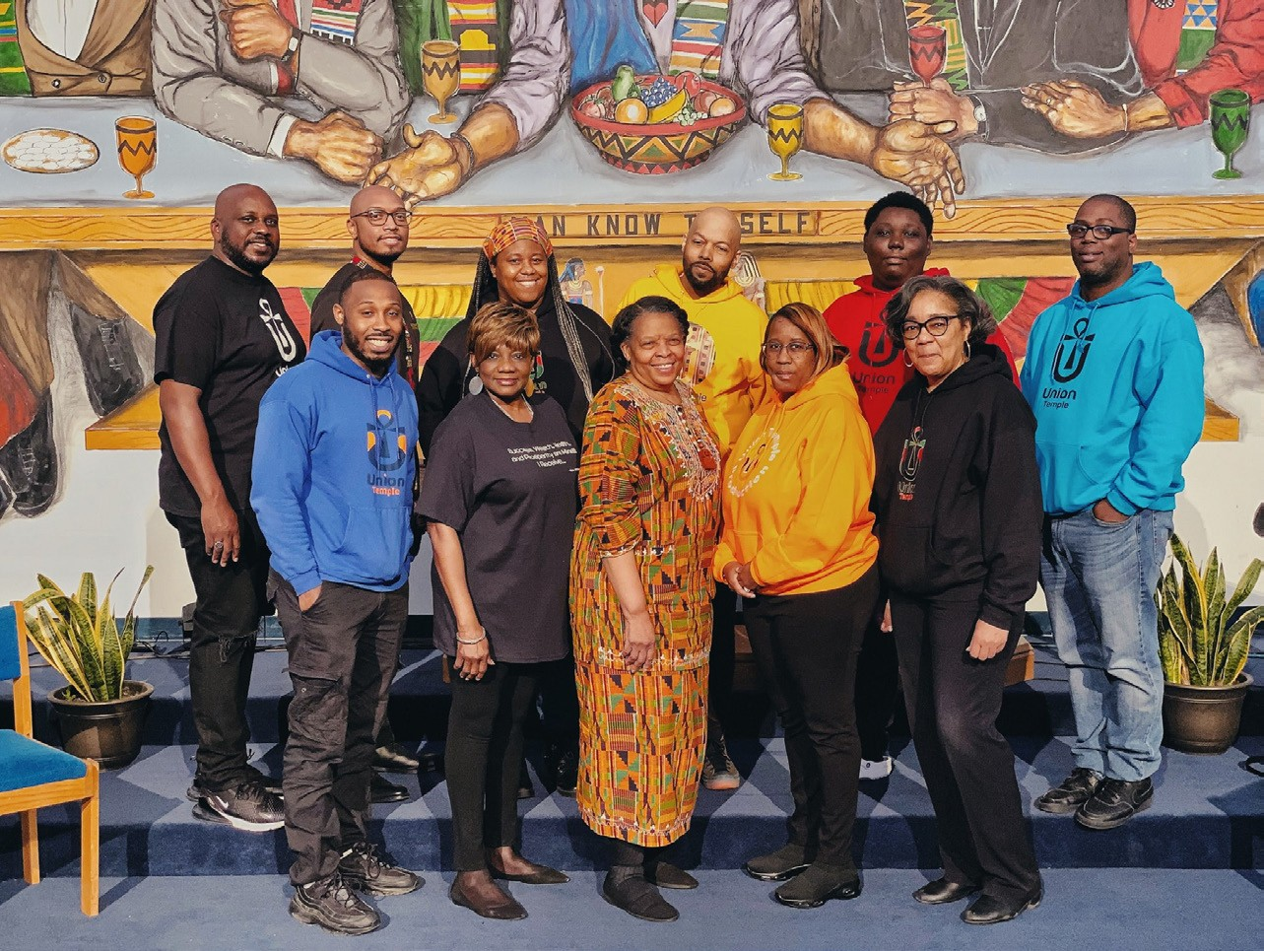

CONGRATULATIONS PASTOR ANIKA!

When you speak we’ll make sure the world listens.
Production

LIGHTS CA M E R A S O U N D
S H I F T.

